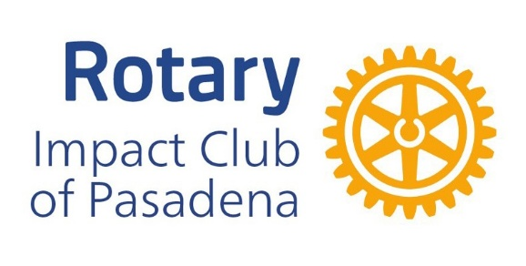
IMPACT Clubs Fact Sheet
What is an IMPACT club?

- Is IMPACT a club or membership type?
  - A: IMPACT is an additional Innovative Club model.
- Is IMPACT a standalone club?
  - IMPACT is a type of Satellite Club (Companion Club 1) .
  - Members are also "Active2" members of its Host club.
  - As an extension of the Host club, IMPACT is not intended to "separate" from the Host, but rather be a service project-focused part of the Host club's membership.
  - However, if desired, it can be a standalone club.
- What is the purpose of the IMPACT club?
  - A: The club's primary mission is community service, perhaps seen as a "service­ only" club without a commitment to traditional meetings, speakers, meals, etc.
  - An IMPACT club's service-only focus without meeting requirements offers Rotary
membership as an opportunity to those who cannot attend meetings for various reasons.
- Do IMPACT club members attend meetings?
  - Members are welcome (but not expected to) attend Host club meetings.
  - Members may also participate virtually in Host club hybrid meetings, if offered.
- How do they decide what service projects to do?
  - A: The IMPACT club creates and executes its own projects, also inviting Host club members to participate.
  - They also assist with Host club projects.
- Are IMPACT members real Rotarians?
  - A: In Rotary International, IMPACT members look just like "Active" members of the Host club.
  - In DACdb, the IMPACT club looks like a club subordinate to the Host club and
has all functionality a Host club (or any club) has.
  - If the IMPACT club chooses, it can have officers, calendar, online registration, PMail, Engagement tracking, etc. in DACdb.

1 A Companion Club acts like a Satellite Club, with no plans to separate from its Host club
2 Rotary International recognizes two member types: Active and Honorary. A member of an IMPACT Club is considered to be an Active member type.

- Where do IMPACT club membership numbers count?
  - IMPACT members are listed as "Active" members of the Host club on all Rotary International membership and Rotary Foundation reports.
- Does an IMPACT club have a board?
  - Generally, the club is self-governing, led by a "Chair" who is likely also on the Host club board.
  - The IMPACT club elects its other key leaders.
- Does the IMPACT club have committees?
  - The club may have some key committee chairs, such as Membership, Community Service, Pl/PR, The Rotary Foundation.
  - IMPACT clubs are encouraged to have a DEi committee or at least a chairperson.
  - The IMPACT club needs an "administration" chair who coordinates with the Host club Secretary and Treasurer.
- Who manages dues billing/collection, etc.
  - Like any Satellite club, the Host club handles all "back office" functions, such as dues billing/collection, new member adds, terminations, etc.
e How are IMPACT club dues handled?
- Like all Rotary Club members, IMPACT Members' dues include RI and District dues, plus whatever the club determines it needs for operational expenses.
- The club dues component for IMPACT members may be the same as or different
from those of the "traditional" Host club members, often lower as there are typically no meals involved and also lower operating costs for the club itself.
- Does an IMPACT club have its own bylaws?
  - The IMPACT club may or may not have its own bylaws.
  - The club can operate under the Host club's bylaws, which do need to be modified to reflect the IMPACT club's operation.
  - If the IMPACT club chooses, it may have its own bylaws.

Video Overview of IMPACT Clubs: https:// youtu.be/ Oh hpBs45-ul

